**Chapter 2 The biology of mind**

1) **Neutral and Hormonal Systems**

1. **Biology, behavior and mind**

Mind≠Brain≠Body

How can brain transplant change a person?

**Everything psychological is simultaneously biological**

The Brain **controls thought, behavior, emotions, and memory**, as well as basic life functions such as breathing and heart rate. The brain consists of the cortex, brainstem, and cerebellum.

The mind is **about mental processes, thought and consciousness**.

The body is about the physical aspects of the brain-neurons and how the brain is structured.

The Brain

2% of our body weight, 20% of our calorie intake

Why is the brain wrinkled?

**The** wrinkled brain creates a greater surface area giving our neurons, or brain nerve cells, more space to create connections and deliver information.

What is the brain made of?

Water, fat and protein

**2. Neutral communication**

**Neurons**: nerve cell; “basic” **building block** of the nervous system

Throughout life, unused neurons wither away

The vast majority of the neurons a person will ever have already formed by the end of the second trimester of pregnancy.

**Neurons don’t do connection**

**Formation of new neurons** in the **hippocampus** (major role in learning and memory) occurs throughout life.

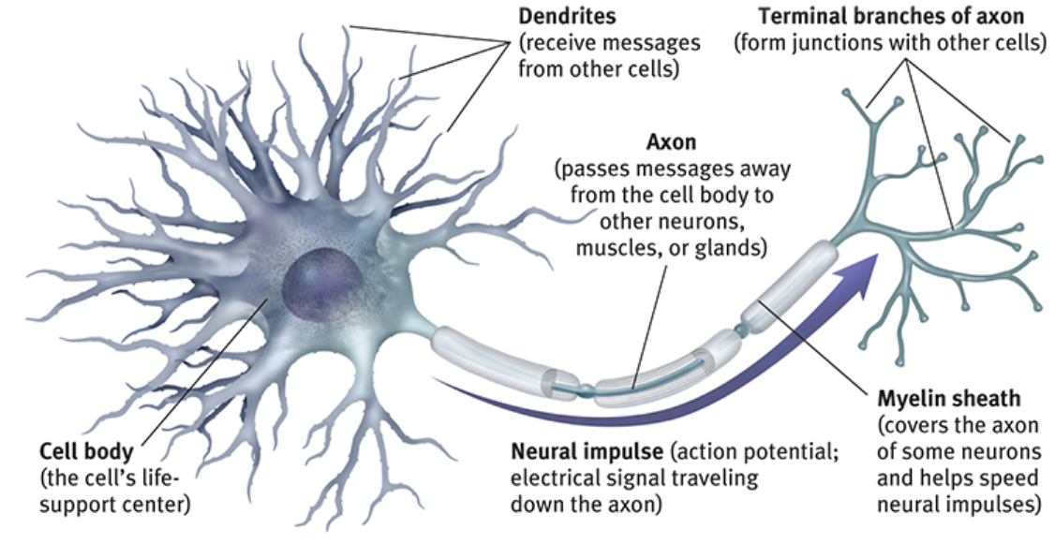

The links between neurons are called **synapses**

The direction goes from the dendrites to Terminal branches of axon

**Dendrites listen, Axon speaks**

**Myelin Sheath**: fatty tissue layer segmentally **encasing the axon** of some neurons;

enables **vastly greater transmission speed** as neural impulses hop from one node to the next.

* Allows for **reflexes**
* Myelin is laid down up to about age 25< neural efficiency, judgement, self-control grow

Young people are usually more impulsive

* **Multiple sclerosis (MS**) is the most common demyelinating disease of the central nervous system

**Glial cells (glia):** cells in the nervous system that **support, nourish and protect neurons**

* Provide **nutrients and insulate myelin**
* **Guide neural connections**
* Mop up **ions and neurotransmitters**
* Participate in information transmission (learning, memory, thinking)

In more complex animal brains, the proportion of glia to neurons increase.

There are **10 times** more glial cells than there are neurons.

Einstein's **brain** had more glial cells relative to neurons in all areas studied, but only in the left inferior parietal area was the difference statistically significant.

Electrical activity

1. **Action potential**: a neural impulse; a brief electrical charge that travel down an axon

* A neuron sends messages by **firing** an action potential
* From 3 miles/ h to more than 200 miles/h
* Neurons generate electricity from chemical events
* Ions [ electricity charged atoms] are exchanged
* Positive-outside/negative-inside state = **resting potential**
* The axon’s surface is selectively permeable
* **Depolarization:** loss of the inside/outside charge difference

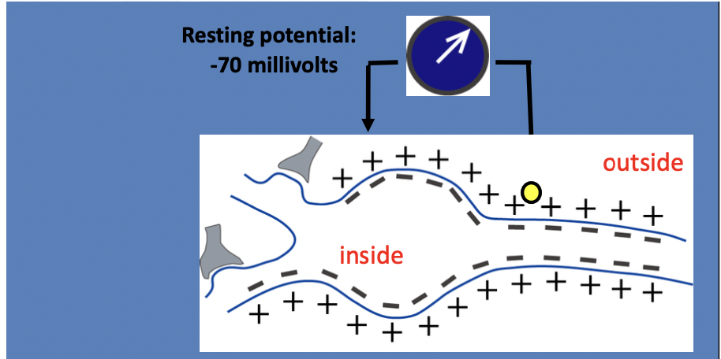

At all time, the neurons receives a lot of **excitatory and inhibitory** signals

Body cell: adds up **excitatory** and **inhibitory** messages

The neuron releases an action potential when the electrical charge reaches the threshold of

-55mV

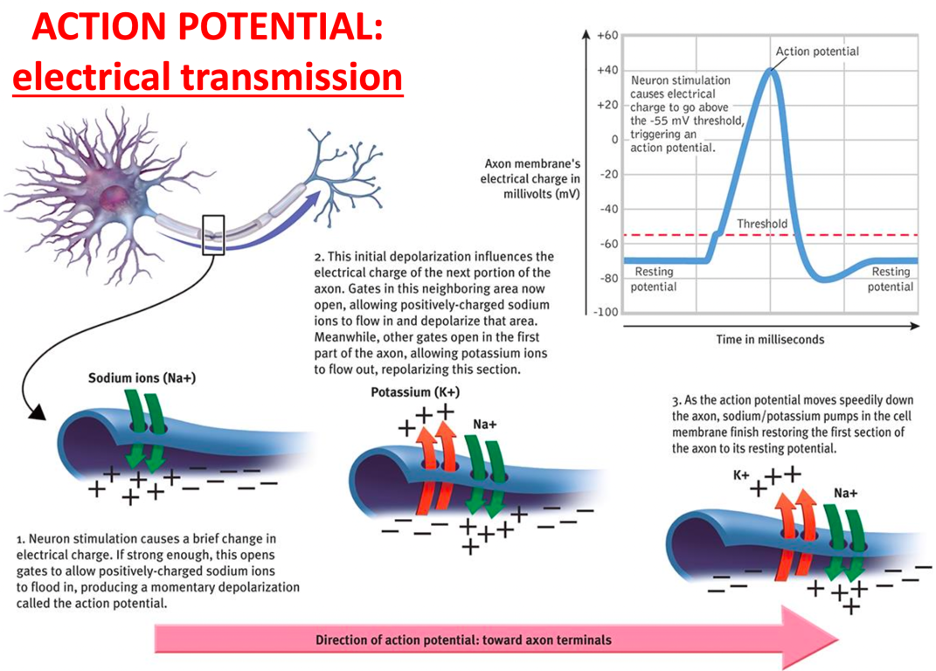

**3. The Nervous System**

The endocrine system works together with the nervous system **to influence many aspects of human behaviour**, including growth, reproduction, and metabolism. And the endocrine system plays a vital role in emotions.

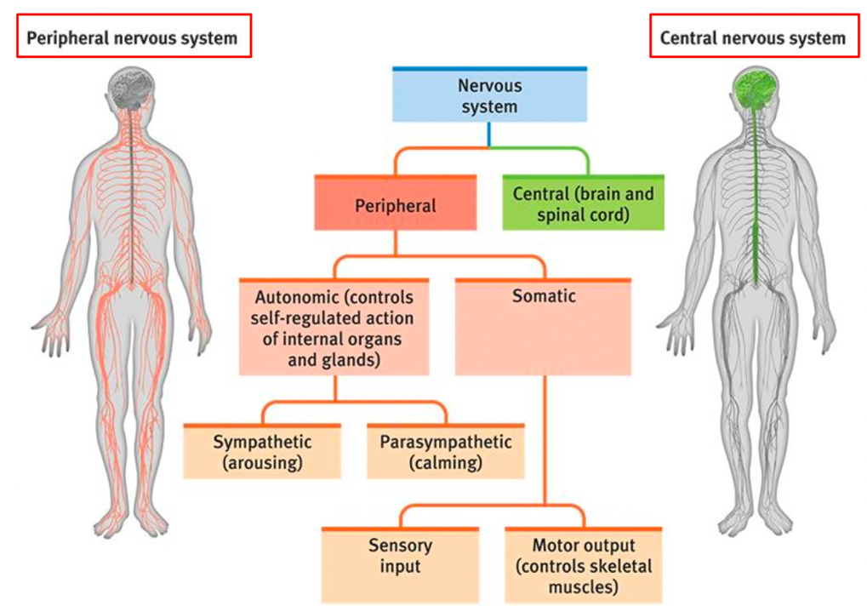

Information travels in the nervous system through **3 types of neurons**:

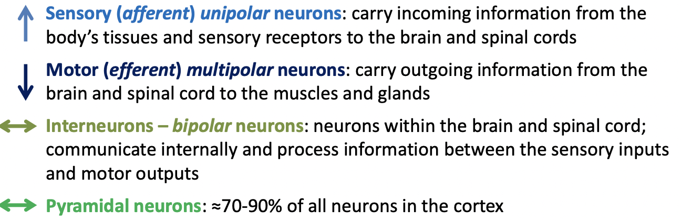

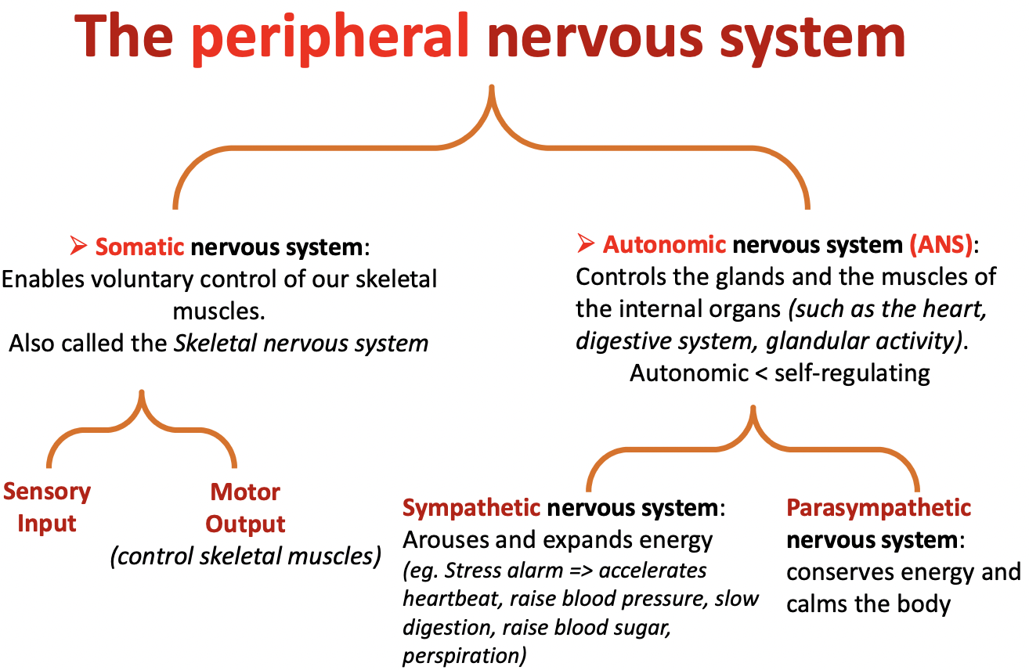

**Sympathetic & Parasympathetic** systems work together to keep us in a state of **homeostasis**.

**Homeostasis: psychological and physiological balance achieved when one's needs and desires have been met.**

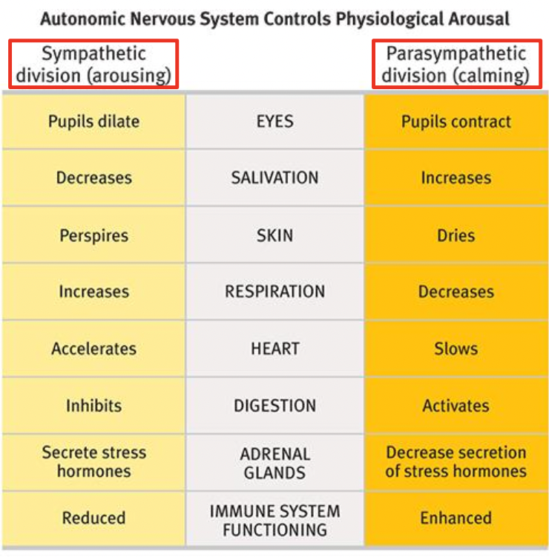

The **Autonomic Nervous System** arouses the body in a crisis and calms it when danger passes.

* The body’s response to danger is coordinated and adaptive

The **enteric nervous system (ENS)** is a large division of the peripheral nervous system that **can control gastrointestinal behavior independently of central nervous systems (CNS) input**.

The **enteric nervous system** is our “second brain”

* There are one billion neurons in the Enteric Nervous System
* “Gut information” can reach brain areas related to **morality, emotional processing and self-awareness**

It can be sent to our cognition without us knowing it.

* 95% of all existing bacteria are harmless, necessary for our survival

Role in cleaning the colon

Role in digesting

Role in weight variation between individuals

Role is **personality and behaviors**.

1. **The central nervous system**

**Brain + Spinal cord**

The brain is estimated to have 86 billion neurons and 100 trillion connections

* Connections matter more than neurons

(we are born with all the neurons we can have)

The brain’s neurons cluster into **neural networks**

* Experience strengthens connections

**Neurons that fire together wire together**

* Repetition makes connections solid

Neurons ≠ Brain cells

* All brain cells are not neurons: Glial cells are brain cells, but they are not neurons
* All neurons are not brain cells: There are neurons in the peripheral nervous system, the heart and the gut
* The mind is more than neurons: it takes the specialized organization of neurons in the body (including the brain) to produce cognitive processes that we experience as the mind

1. **The endocrine system**

The endocrine system’s glands secrete **hormones**

**Hormones**: Chemical messengers manufactures by the endocrine glands

Travel through the bloodstream, and affect other issues (including the brain)

When hormones act on the brain, they influence our interest in sex, food, moods

Endocrine system is **slower** than the nervous system, **but endocrine messages tend to outlast the effects of neural messages.**

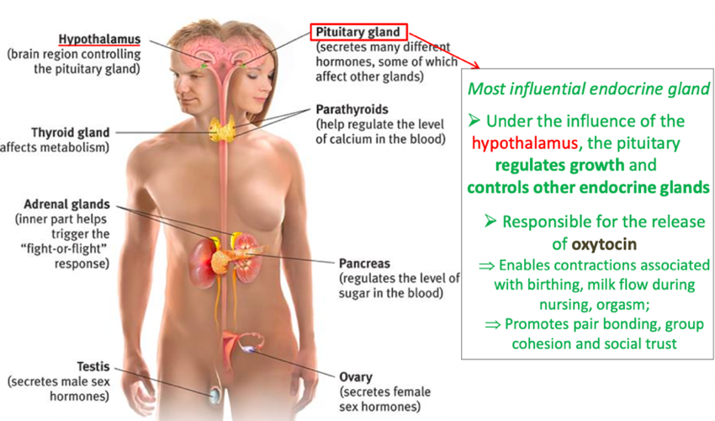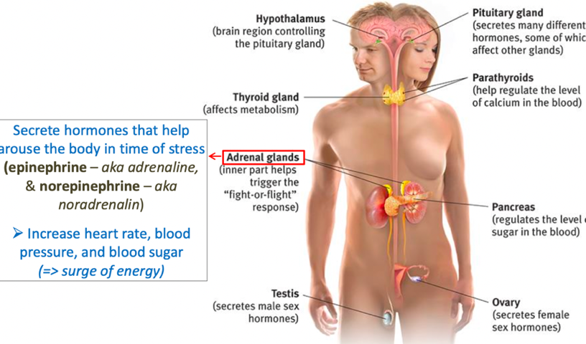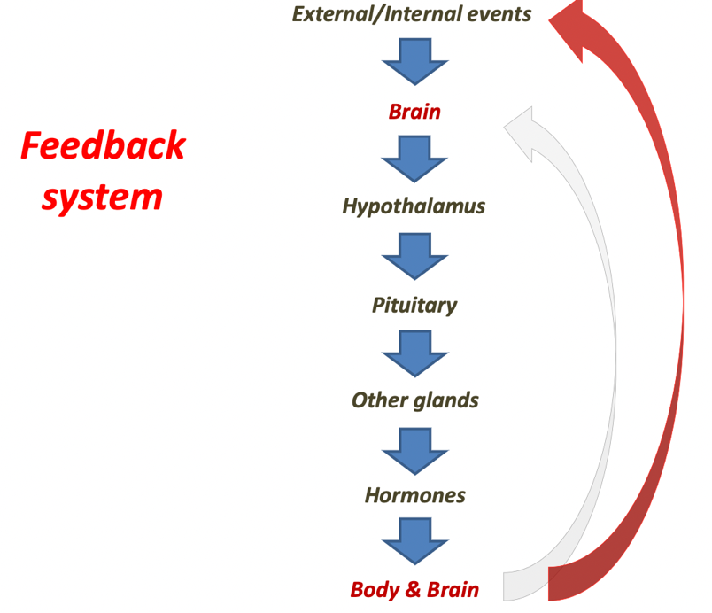

**2) Tools of discovery, Older brain structures, Limbic system**

1. **The tools of discovery: having our heads examined**

Case studies of **brain damages** => function localization

Today: stimulation of brain parts **electrically, chemically** or **magnetically** to note the effect

**Electroencephalogram (EEG):** amplified recording of **waves of electrical activity** sweeping across the brain’s surface

**Magnetoencephalography (MEG**): measures **magnetic fields** from the brain’s natural **electrical activity**

The speed and strength of the magnetic fields enable to understand how certain tasks influence brain activity

**Positron emission tomography (PET)** scan: a visual display of **brain activity** that detects where a radioactive form of **glucose** goes while the brain performs a given task

**Magnetic resonance imaging (MRI):** a technique that uses **magnetic fields** and **radio waves** to produce computer-generated images of soft tissue. It shows brain anatomy.

**Functional MRI (fMRI):** a technique for revealing brain activity by comparing successive MRI scans. it shows **brain function as well as structure**, image metabolic function

**CORRELATION ≠ CAUSATION**

Neuroimaging and neuropsychology make **correlations** between brain states and psychological states, but it doesn’t guarantee the causal link in between.

The fact that a brain lesion(damage) or a brain activity **correlates with** a mental function does not mean it ***causes*** it.

Eg:

hands help you to grab things, but hands do not cause grabbing

Hands do more than grabbing

* A brain structure is often involved in more than one mental function

You can still grab without your hands

Brain plasticity – when a brain structure leads to the impairment of a mental function, this mental function can sometimes be taken over by alternative brain structures

Conclusion: **The human body is an integrated system where all the parts are connected.**

Cognition is determined by all system working as a whole.

**2.** **Older brain structures**

**The brainstem**: the oldest part and central core of the brain that responsible for **automatic survival functions**

The brainstem is a **crossover point** where most nerves from one side of the body connect with the opposite side

**Medulla**: base of the brainstem, controls **heartbeat and breathing**

**Pons**: helps **coordinate movements** and control sleep

**The thalamus**: the brain’s **sensory control center**.

**The reticular formation**: allow multitasking, plays an important role in **controlling arousal**

**The cerebellum**: the “little brain”

Processing sensory input, **coordinating movement output and balance**, enabling non-verbal learning and memory, help us judge time

Mostly control of the movement and learning of the movements

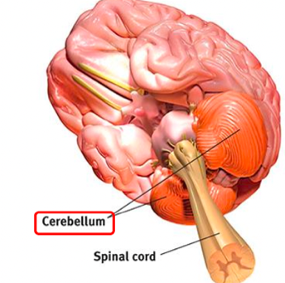

**3. the Limbic system**

**The amygdala**:

two neural clusters in the limbic system; linked to **fear** and **aggression** (eg: Amygdala Hijack)

**Hypothalamus**:

directs several **maintenance activities** (thirst, eating, drinking, body temperature, sex behavior), helps govern the **endocrine system**, linked to **emotion and reward,** alsohelps maintain a homeostatic internal state

**Hippocampus**:

a neural center located in the limbic system; helps **process explicit (conscious) memories**—of facts and events—for storage

Memories of facts and events for storage

**The only part of the brain where we have new neurons created**

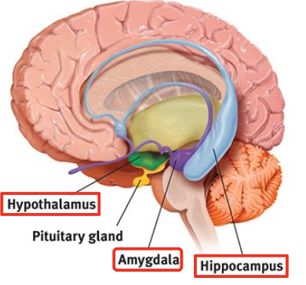

**3) The cerebral cortex**

**Cerebral cortex**: a layer of tightly packed neurons that **covers the outer surface** of the brain’s two cerebral hemisphere. if you opened a person’s skull, the cortex is what you would see.

Each of the two cerebral hemisphere is divided into four lobes named for their location within the skull.

**1.** **structure of the cortex**

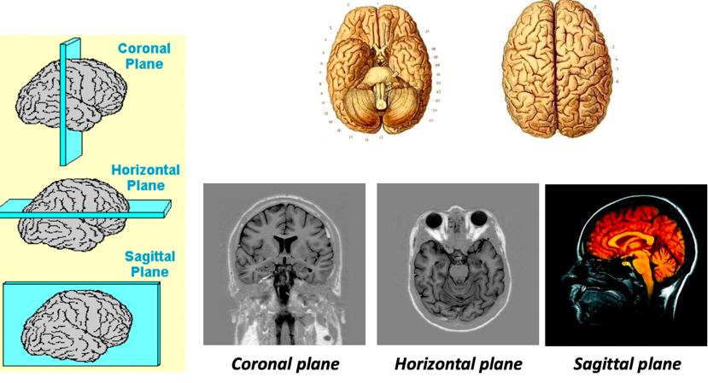

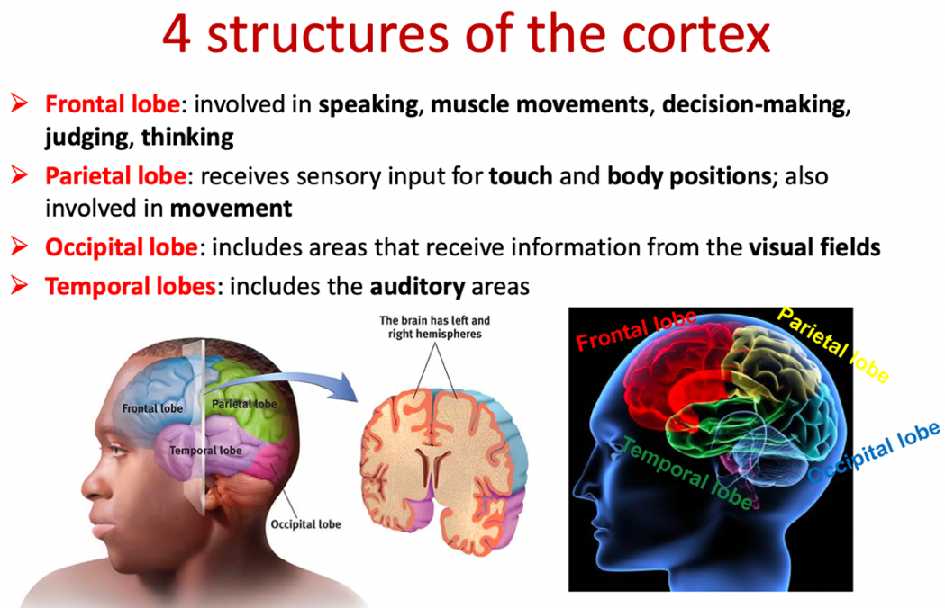

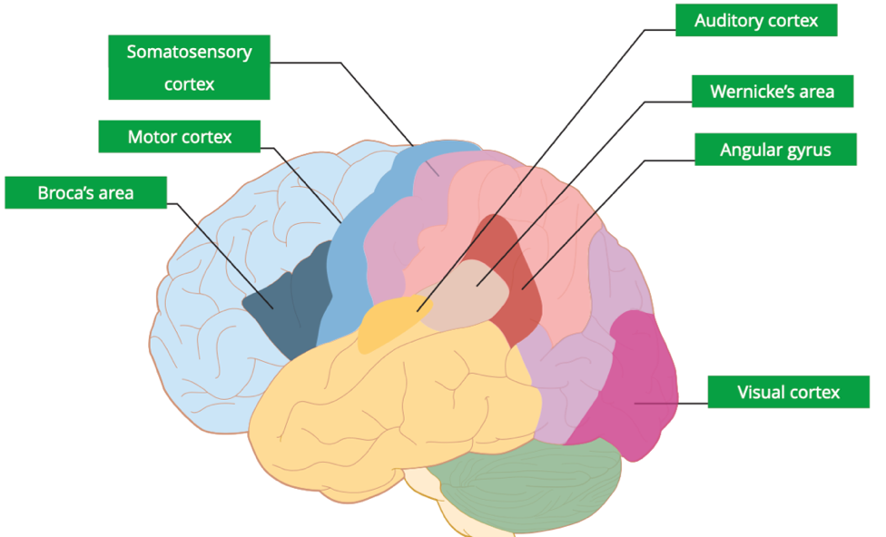

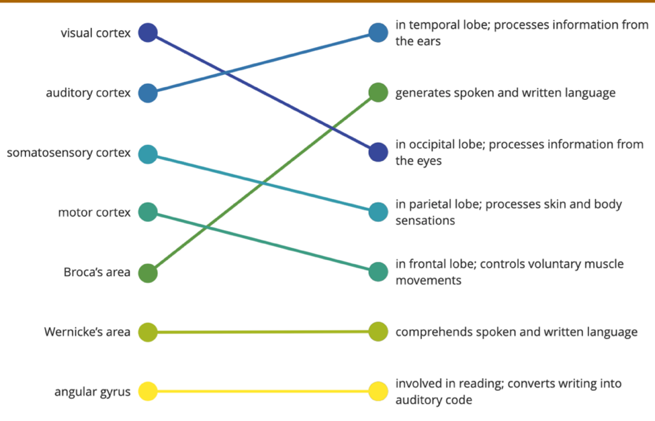

Frontal lobes: judgment, planning, and processing of new memories

Cerebrum: two cerebral hemispheres contributing 85% of the brain’s weight

**2. Functions of the cortex**

Motor functions:

Movement is **the only way** to act on the environment (with the release of hormones)

**OUTPUT: Motor cortex**: control of **voluntary** movements

**INPUT: Somatosensory cortex**: registers and processes body touch and movement sensations

Motor neurons carry outgoing information from the brain and spinal cord to the body's muscles, organs and tissues.

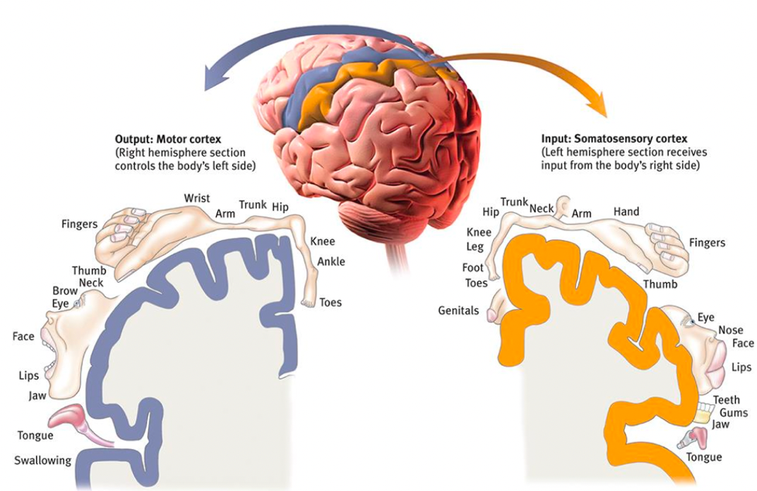sagittal plane

Sensory functions

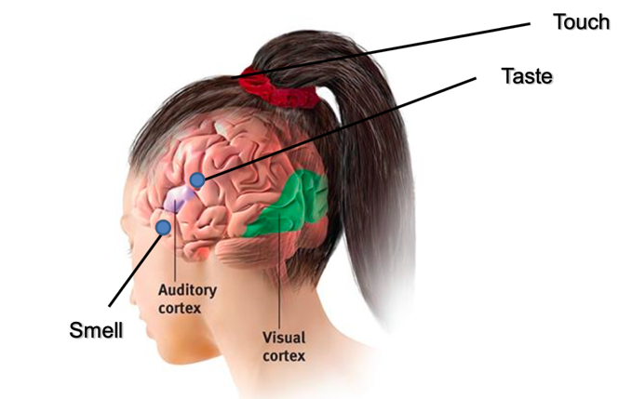coronal plane

LSD => increased **connectivity** of the visual cortex with other brain regions.

**Association areas**: areas of the cerebral cortex that are involved in “higher” mental functions (such as **learning**, **remembering**, **thinking** and **speaking**)

**<Prefrontal cortex**: enable judgement, planning, and processing of new memories. Last part of the brain to develop

**<Frontal lobe**: **emotions, morality**

**<Parietal lobes**: enable **mathematical** and **spatial reasoning**

**<Temporal lobes**: face recognition

Many islands of brain activity work together

Our mental experiences arise for coordinated brain activity

The divided brain

Lateralization: hemispheric specialization. Left and right hemisphere serve differing functions

Corpus Callosum and split-brain patients: the mind as an interpreter

**Corpus Callosum**: the large band of neural fibers **connecting the two brain hemispheres and carrying messages between them**

**Split-brain**: a condition in which the corpus Callosum is severed.

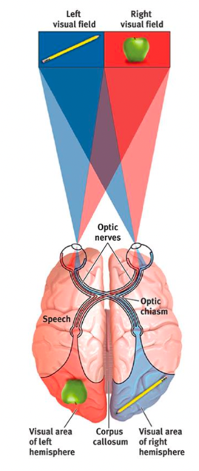

Information from the left half of your field of vision goes to your right hemisphere. Information from the right half of your vision goes to you left hemisphere, which usually controls speech.

Data received by either hemisphere are quickly transmitted to the other across the corpus callosum. In a person with a severed corpus callosum, this information-sharing does not take place.

1. **Brain plasticity:**

**Plasticity**: the brain’s ability to change by reorganizing after damage or by **building new pathways** based on experience.

**Neurogenesis**: the formation of new neurons

Some neuron tissues can **recognize** in response to damage.

**Constraint-induced therapy**: rewire brains and decrease the impact of a stroke or traumatic brain injury (TMI)

**Sensory systems can assume the function of another sensory system if given a learning period.**